Lecture 3 – Theory of Computing – Sematic Tableaux

Logical equivalence:

* When are two formulas equivalent?
* When no interpretation can distinguish them: under all interpretations ρ, [A1]ρ ≡ [A2]ρ

Traditional logical equivalence syntax:

New logical equivalence syntax:

Algorithm:

* Input: A formula in propositional logic (say ϕ)
* Output: A semantic tableau (essentially a tree of sub-formulas)

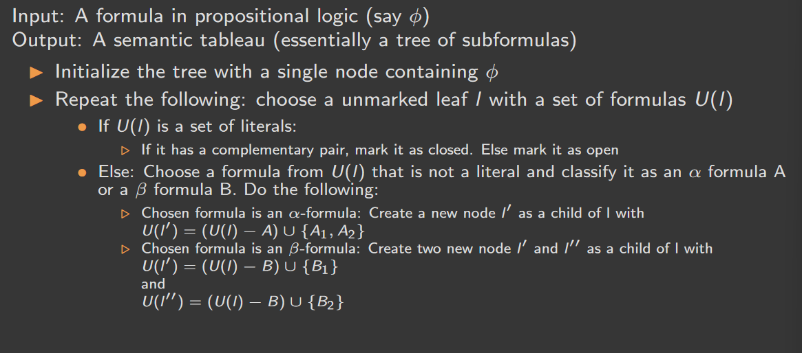

Example:

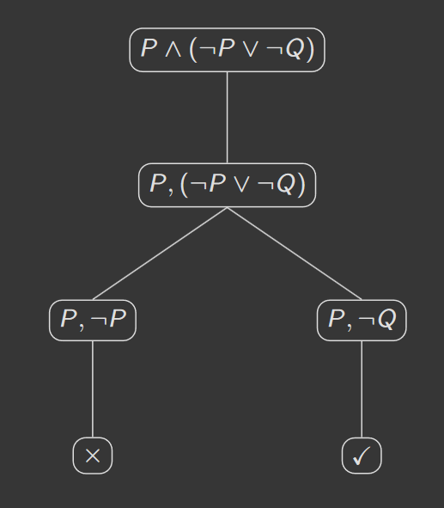

Another example (two ways of showing the same tableaux construction):

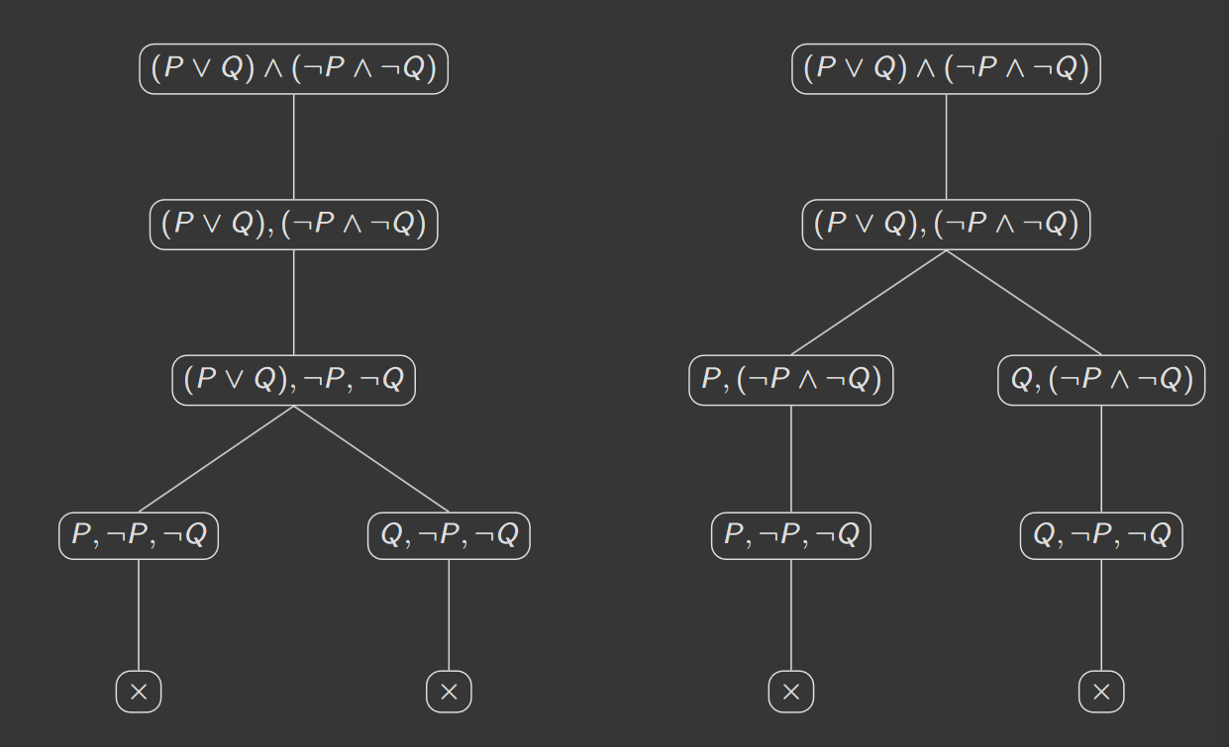

Connecting tableaux construction to logical entailment:

* Theorem: unsatisfiable(A) if Tableaux(A) is closed
* Corollary: satisfiable(A) if Tableaux(A) is open
* Corollary: valid(A) if Tableaux(¬A) is closed